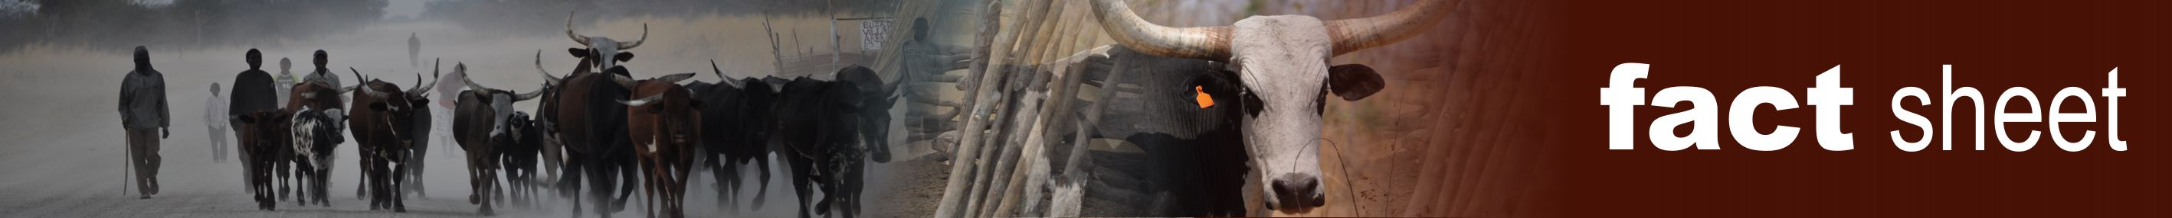
African horse sickness (AHS)
Author: Dr Melvyn Quan
Adapted from: Coetzer, J.A.W and Guthrie, A.J. 2004. African horse sickness, in Infectious diseases of livestock, edited by J.A.W. Coetzer & R.C. Tustin. Oxford University Press, Cape Town, 2: 1231-1264
Licensed under a Creative Commons Attribution license.

Introduction
African horse sickness (AHS) is a peracute, acute, subacute or mild infectious but non contagious disease of equids caused by African horse sickness virus (AHSV). The virus is classified in the genus Orbivirus of the family Reoviridae, of which there are nine serotypes, all transmitted by Culicoides midges. AHS is a World Organization for Animal Health (OIE) - listed disease and manifests pyrexia and clinical signs compatible with impaired respiratory and circulatory functions, characterized by oedema of subcutaneous and intermuscular tissues and of the lungs, transudation into the body cavities and haemorrhages on serosal surfaces.
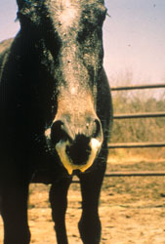
Discharge of large quantities of frothy, serofibrinous fluid from the nostrils are seen in some horses with the pulmonary form of African horse sickness prior to death

The mortality rate in horses, the most susceptible species, may be as high as 95 per cent, while mules are less susceptible and donkeys with rare exceptions only develop inapparent infections.

Salient features of ASF
In southern Africa, the appearance of AHS is seasonal, sometimes starting during December, but usually in January and peaks in March or April. Following the first frosts, the disease disappears abruptly until the next summer. In frost-free areas, such as the Lowveld, the disease may occur throughout the year.

Four forms of AHS occur in horses: the peracute, “pulmonary” or “dunkop” (“thin head”) form, i.e. cases in which subcutaneous swelling of the head is absent); the acute or “mixed” form; the subacute, oedematous, “cardiac” or “dikkop” (“thick” or “swollen head”) form and the horse sickness fever form.
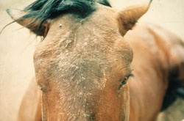
Facial swelling and oedema of the supraorbital fossae

In addition to equids, dogs are the only other species that contract a highly fatal form of the disease after infection with AHSV. All reported natural cases in dogs have resulted from the ingestion of infected horse meat, but experimentally they are also susceptible to infection by inoculation of virus by various routes.

Where does ASF occur?
AHS is endemic to sub-Saharan Africa, with recent reports of outbreaks in southern Africa, Ethiopia Nigeria and Senegal. Occasional outbreaks have, in the past, been reported in northern Africa, the Iberian Peninsula and the Middle East.

What triggers an outbreak of ASF?
The virus is transmitted biologically by Culicoides spp., of which C. imicola and C. bolitinos have been shown to play an important role in Africa. AHS prevalence is therefore influenced by climatic and other conditions which favour the breeding of Culicoides spp. Early and heavy rains followed by warm, dry spells favour the occurrence of epidemics. In the open, most animals become infected during the period between sunset and sunrise when Culicoides midges are most active. between them and the pigs they feed on, with the ticks serving as long-term hosts of the virus.

Prevention and control
In endemic areas and in regions where AHS occurs almost every year, annual vaccination of horses is a very practical means of control. Although prophylactic immunization against AHS is a very efficient method of preventing serious losses, it cannot be relied upon fully to protect horses against infection or disease. However, the majority of horses that have received three or more courses of immunization are usually well protected against the disease. In southern Africa, annual immunization with a live polyvalent attenuated vaccine in late winter or early summer (September to November), which is some time before the peak AHS season, is advocated and allows immunized animals to respond adequately to the vaccine before challenge by natural exposure. A commercial polyvalent vaccine contains attenuated strains prepared in two components, one of which is trivalent (serotypes 1, 3 and 4) and the other of which is quadrivalent (serotypes 2, 6, 7 and 8). A course of immunization consists of the administration of these component vaccines three weeks apart. Serotypes 5 and 9 are not included in the vaccines as serotypes 8 and 6, respectively, afford adequate cross protection.

Infection of susceptible horses can be prevented to a large degree by stabling them some hours before sunset and letting them out a few hours after sunrise, as Culicoides spp. are nocturnal and are not inclined to enter buildings. The application of insect repellents and the use of insecticides on animals' coats will also discourage Culicoides from feeding on them.

Find out more
The CPD module on AHS provides an in-depth description of AHS, from the distribution of AHSV in Africa and historical outbreaks outside Africa, transmission of the virus by Culicoides midges, and factors affecting the seasonal peak in incidence of the disease, to how the virus causes such severe clinical signs in horses, the different clinical forms of AHS, other diseases that may be confused with AHS, the latest diagnostic tests, developments in new generation vaccines, measures to control an outbreak of AHS, and the latest trade issues.

