African Horse Sickness
Author: Dr Melvyn Quan
Adapted from: Coetzer, J.A.W and Guthrie, A.J. 2004. African horse sickness, in Infectious diseases of livestock, edited by J.A.W. Coetzer & R.C. Tustin. Oxford University Press, Cape Town, 2: 1231-1264
Licensed under a Creative Commons Attribution license.

Epidemiology
AHS is endemic to sub-Saharan Africa, with recent reports of outbreaks in southern Africa, Ethiopia Ghana, Nigeria and Senegal. Occasional outbreaks have, in the past, been reported in northern Africa, the Iberian Peninsula and the Middle East (Figure 1). Its intrusion into North Africa and countries around the Mediterranean Sea and Asia is impeded by the Sahara desert. Apparently AHS does not occur in Madagascar or Mauritius.
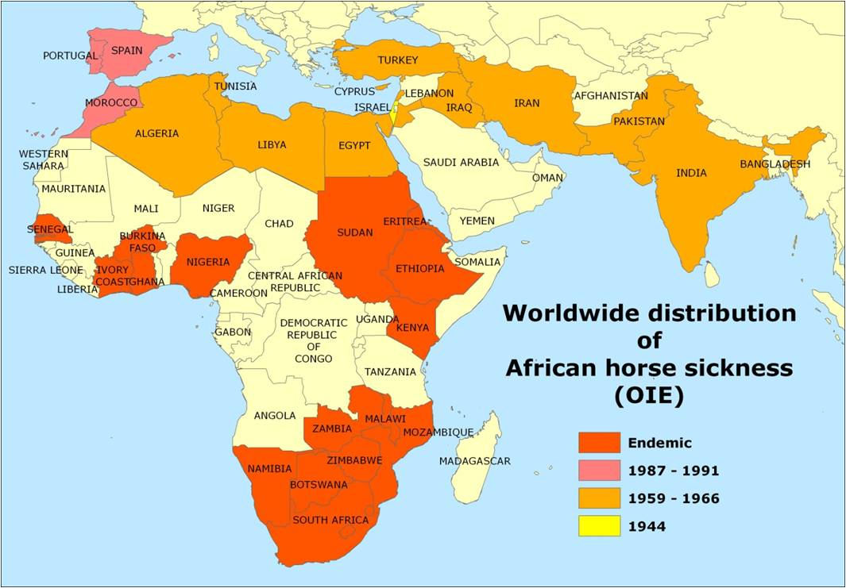
Fig. 1: Worldwide distribution of African horse sickness
In South Africa, AHS appears to be endemic in the low-lying, eastern, summer-rainfall areas of the country. Although the inland plateau “Highveld” regions and most of the three Cape Provinces are usually free of the disease, the infection has sometimes extended into these areas and caused serious losses. According to Du Toit, heavy losses were reported even at Belfast, a town situated at almost the highest altitude (about 2 100 metres above sea level) in Mpumalanga, during the severe epidemic of 1923. Outbreaks of AHS in the Cape Peninsula of the Western Cape Province have only been reported in 1967, 1990, 1999, 2001, 2004, 2006 and 2011, all associated with the importation of infected horses.
Heavy rains followed by warm, dry spells favour the occurrence of epidemics. In South Africa, the first cases of AHS usually occur in the beginning of February, but the most serious outbreaks are commonly encountered in March and April. Following the first frosts, which are usually experienced towards the end of April or in May, the disease disappears abruptly. However, in the Lowveld region, where frost is less common, cases of the disease may continue into May and June.
During outbreaks of AHS in endemic areas, different virus serotypes may be active simultaneously within an area, but one serotype usually dominates during a particular season, followed the next year by the dominance of another serotype. While all serotypes are detected with varying frequencies in southern Africa, the most common circulating serotypes currently in northern Africa are serotypes 2, 4 and 9. Serotypes 3, 4 and 9 have been recorded outside Africa.
AHS affects primarily equine species. Horses are the species most susceptible to the disease (mortality rate between 70 to 95 per cent) and mules less so (mortality rate of 50 to 70 per cent). Donkeys and zebras are very resistant, with most infections subclinical. Horses of all breeds are in general equally susceptible to AHS but variation in susceptibility to the same virus of individual horses has been reported. There are horses in North and West Africa which descended from animals present there since 2 000 BC, and which have apparently acquired natural resistance to AHS. Theiler was unable to produce fatal disease in donkeys inoculated with large quantities of virulent blood; at most a mild fever reaction was produced. Donkeys in the Middle East, however, appear to be far more susceptible to disease (the mortality rate may reach 10 per cent) than donkeys in Africa. Zebras are highly resistant to the disease and only show a mild fever following experimental infection.
Foals born to immune mares acquire passive immunity by the ingestion of colostrum soon after birth. This immunity progressively declines as a result of catabolism of the immunoglobulins until it is completely lost after about four to six months. Foals born to fully susceptible mares are just as susceptible as are previously unexposed adult horses.
In addition to equids, dogs are the only other species that contract a highly fatal form of the disease after infection with AHSV. All documented natural cases in dogs have resulted from the ingestion of infected horse meat, but experimentally they are also susceptible to infection by inoculation of virus by various routes. AHSV serotype 9 has been isolated from the blood of stray dogs in Egypt, and antibodies to AHSV have been detected in the sera of dogs in India and South Africa. The role dogs play in the epidemiology of AHSV, if any, is unknown.
Besides early reports, little evidence of antibody to AHSV has been detected in domestic or wild ruminants with the possible exception of camels. Pigs, cats and monkeys are refractory to infection with AHSV.
Amongst wildlife, antibodies to AHSV have only been found in zebras, African elephants (Loxondonta africana) and black and white rhinoceroses (Diceros bicornis and Ceratotherium simium). However, the possibility that elephants are reservoir hosts of AHSV is questioned as a 100 elephants tested in an endemic AHS area in South Africa had high complement fixing titres to both bluetongue and AHS viruses, but no neutralizing antibodies to these viruses, indicating that the sera of elephants reacts non-specifically in the complement fixation test. In contrast, in a similar study in Kenya, elephants were shown to have neutralizing antibody to AHSV.
AHS is not contagious. AHSV is transmitted biologically by Culicoides spp., of which C. imicola and C. bolitinos have been shown to play an important role in Africa. Culicoides variipennis, a midge prevalent in the USA but not present in southern Africa, can transmit the virus to chicken embryos in the lab. In Europe, C. dewulfi, C. obsoletus sensu strictu, C. scoticus, C. pulicaris, and C. chiopterus have been implicated as vectors of the related bluetongue virus. Culicoides midges, in general, breed in damp soil rich in organic matter, however C. bolitinos breeds in bovine dung, and it therefore not as dependant on annual rainfall and soil-type.
Adult midges become infected by taking blood meals from viraemic animals. Virogenesis in the midge is approximately eight days after which AHSV localises in the salivary glands and is transmitted to the next host when the midge takes its next blood meal. Both infection rate and rate of virogenesis of AHSV within midges are temperature dependent: the lower the temperature, the lower the infection rate and longer the virogenesis. Transovarial transmission and overwintering of AHSV in Culicoides spp. has not been demonstrated.
Free-ranging animals become infected with AHSV during the period between sunset and sunrise when midges are most active. The virus spreads by movement of either infected vertebrate hosts which then infect vectors in the “new” region, or vectors. AHSV can be distributed over great distances if equids incubating AHS are translocated by land, sea or air. During their lifetimes midges remain generally within a radius of a few kilometres of the site where they breed, but it has been postulated that they can be borne for many hundreds of kilometres in air currents. It has been suggested that infected midges transported by wind were responsible for the spread of the disease over the sea from Senegal to the Cape Verde Islands in 1943, from Turkey to Cyprus in 1960 and from Morocco to Spain in 1966.
It has been shown that a continuous transmission cycle of AHSV between Culicoides midges and zebras exists in the Kruger National Park in South Africa. Under such circumstances a sufficiently large zebra population can act as a reservoir for virus. It has also been suggested that donkeys may play a similar role in parts of Africa where there are large donkey populations. In view of the high mortality rate in horses, this species is regarded as an accidental or indicator host. Horses that have recovered from the disease do not remain carriers of the virus, which explains the failure of the disease to become permanently established outside tropical and subtropical Africa, despite the occurrence of the many outbreaks that have occurred outside endemic areas.

