Helminth infections of wildlife:
The helminths of carnivores
Author: Prof. Joop Boomker
Licensed under a Creative Commons Attribution license.

Table of Contents

Introduction 2
Infections of the gastro-intestinal tract 2
Infections of the skin 3

Introduction
As is the case with the antelope and pigs, the carnivores are also not affected by worms, given that they are well-fed and that the worm-infections are not overwhelming. It is quite conceivable that the high mortality of young lions is due to malnutrition combined with parasite infections, especially the hookworms Ancylostoma and Galonchus. Little is published on helminths diseases of free-living lions and leopards (Boomker, Penzhorn & Hotak, 1997).

Infections of the gastro-intestinal tract
Ancylostoma and Galonchus are virulent blood suckers and can cause severe anaemia in a very short time.
Spirocerca lupi has been recorded from a growth on the oesophagus of a lion that was kept at a zoo.
Cylicocyclus spp. occurs in nodules in the stomach of lions and leopards, and a non-pathogenic Physaloptera spp. in that of cheetahs.
Toxocara and Toxascaris presumably behave in the same way in lions as they do in cats and dogs, and therefore have a more severe influence on the young animals that on the older ones. These ascarids compete with the host for available nutrients.
Several Taenia species occur in the small intestine of lions and leopards, and as is the case with similar species in dogs, the tapeworms do not seem to do significant damage. Species include Taenia regis, Taenia crocutae, Taenia hyaenae and Taenia gonyamai.
Echinococcus is one of the worst helminth zoonoses and man is an intermediate host. Whenever dealing with carnivores, including cats and lions, one should always wear gloves, and definitely not eat, drink or smoke. The strain of Echinococcus that is found in lions is known as Echinococcus granulosus felidis as it is the strain that infects felids, while E. granulosus granulosus infects canids.
The tapeworm genera Mesocestoides and Dipylidium have been recorded from lions and leopards, but are of little importance.
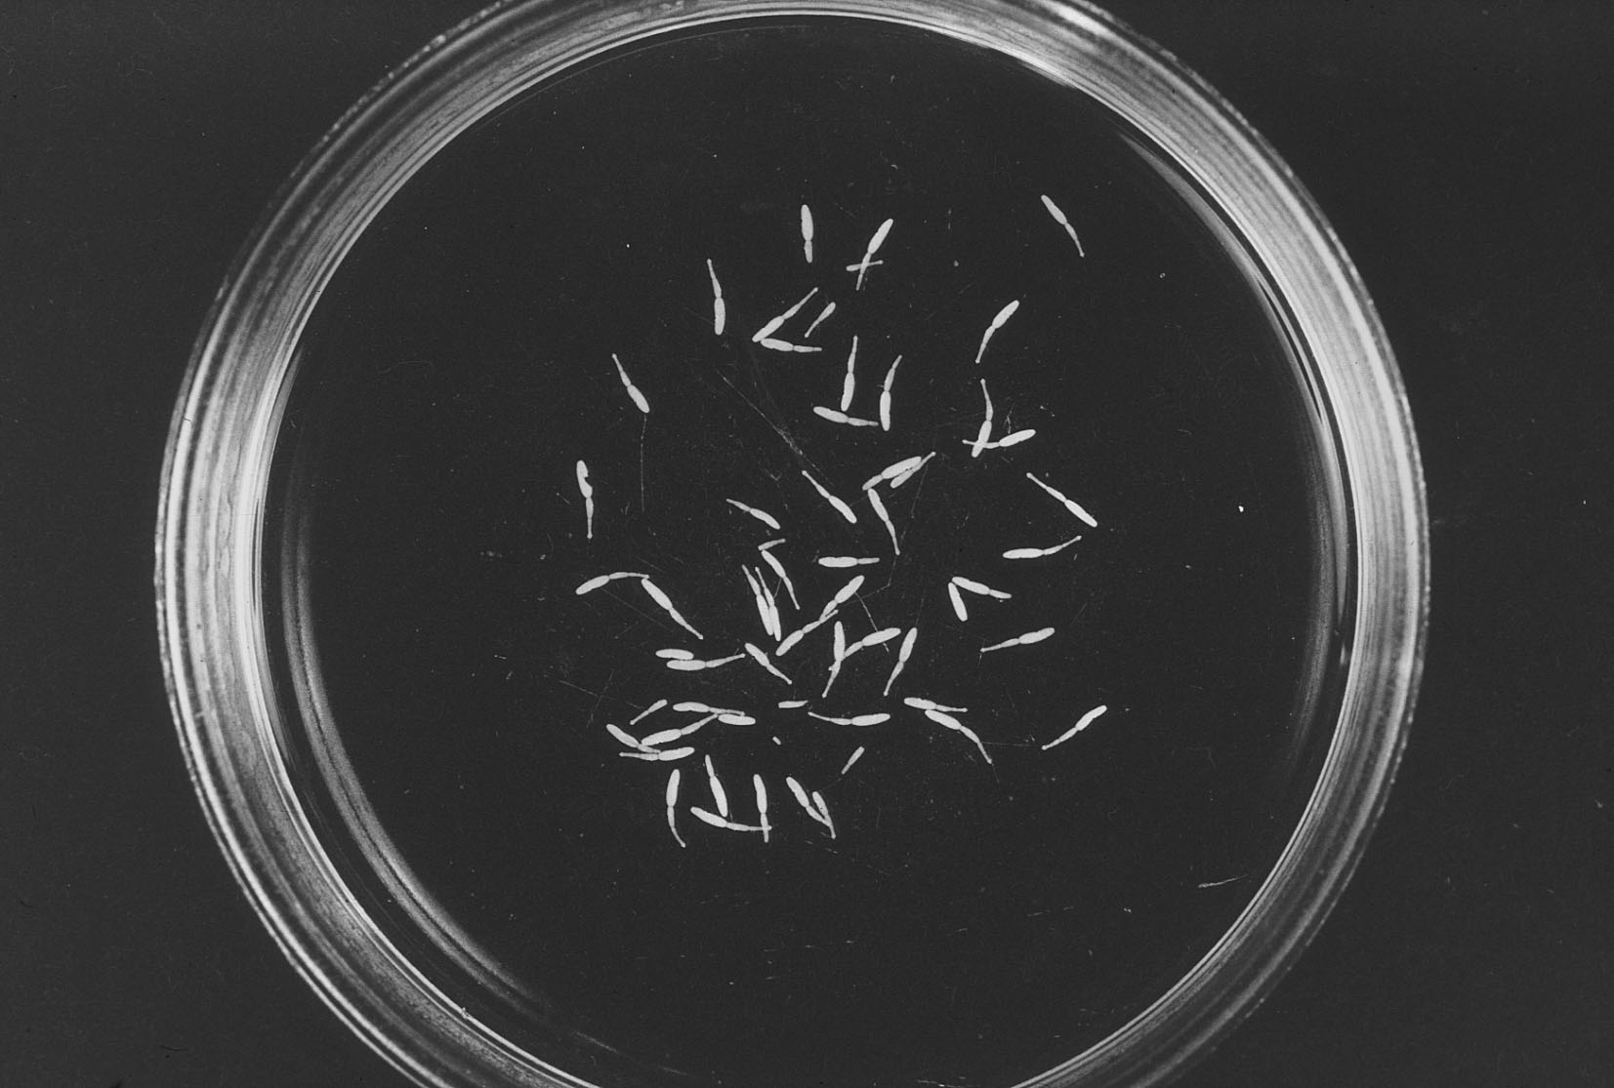
Fig. 31: Fully grown echinococcus sp. From the intestine of a lion. The helminths are very close to their actual size.

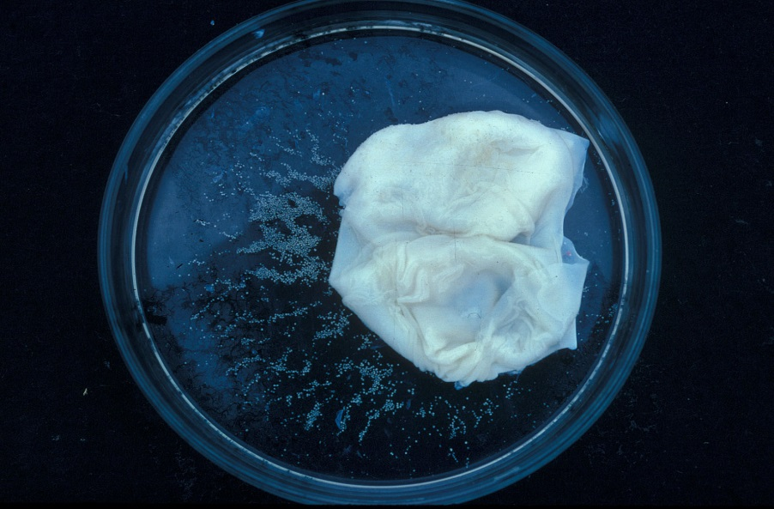
Fig. 32: An opened hydatid cyst with the hydatid sand, which are protoscoleces of the next generation of Echinococcus

Infections of the skin
A surprisongly large number of lions in the KNP suffer from cutaneous dirofilariosis, cause by the filarid nematode Dirofilaria sudanensis. Clinically it manifests as a large soft lump under the skin, but does not seem to cause much discomfort. The nematode is an extremely long one that lies curled up in the subcutis.
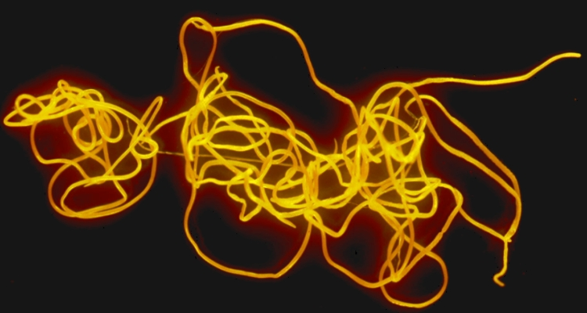
Fig. 33: Dirofilaria sudanensis from the subcutis of a lion.

