Helminth infections of wildlife:
Selected helminthoses in antelope
Author: Prof. Joop Boomker
Licensed under a Creative Commons Attribution license.

Table of Contents
Introduction 4
Infections of the lungs and trachea 4
Infections of the gastro-intestinal tract 6

Helminths of the oesophagus and forestomach 6

Helminths of the abomasum 7

Helminths of the small intestine 11

Helminths of the large intestine 12
Infections of the liver 13
Infections of the cardiovascular system 16
Infections of the skin and adnexa 18
Infections of the musculature 20
Infections of the nervous system 20

Introduction
In many regions of South Africa sheep, goats or cattle graze the same pastures as various antelope species. Many of the helminths recovered from the antelopes are those usually encountered in domestic ruminants, especially sheep and cattle, while other helminths of cattle, sheep and antelopes are more host-specific and are rarely encountered in other species. Horak (1979) was able to artificially infect sheep with Haemonchus contortus, Trichostrongylus axei, Trichostrongylus falculatus and Impalaia nudicollis cultured from the faeces of blesbok, Damaliscus pygarthus dorcas, naturally infected with these worms. Haemonchus placei, Longistrongylus sabie, Trichostrongylus colubriformis, Trichostrongylus falculatus, Impalaia tuberculata and Cooperia hungi likewise became established in sheep, goats and cattle infected with larvae cultured from the faeces of impala, Aepyceros melampus. However, H. contortus, T. axei, T. colubriformis and T. falculatus are known from sheep, and H. placei and T. axei from cattle and it is not possible to determine what role cross-infection plays in maintaining the helminth populations in all four the host species.

Infections of the lungs and trachea
The nematodes Dictyocaulus africana, Dictyocaulus filaria, Dictyocaulus viviparus, and Bronchonema magna occur in the bronchi and trachea of a variety of antelopes. Although the last named species was originally described as Bronchonema by Mönnig, it was placed in the genus Dictyocaulus where it remained for a long time before being transferred back into its original genus, Bronchonema.
The Dictyocaulus species and B. magna in their natural hosts produce lesions similar to, but never as severe as, those seen in domesticated ruminants. Initially, the worms cause alveolitis, followed by bronchiolitis and finally bronchitis as they become mature and move to the bronchi. Cellular infiltrates (neutrophils, eosinophils and macrophages) temporarily plug the bronchioles, causing the collapse of groups of alveoli leading to the clinical signs of coughing, dispnoea and breathing with an extended neck. The patent phase is associated with two main lesions, namely a parasitic bronchitis, characterized by the presence of many adult worms embedded in a white frothy mucus. Secondly, a parasitic pneumonia occurs, characterized by collapsed areas around infected bronchi. The pneumonia is the result of aspirated eggs and L1 which act as foreign bodies and provoke pronounced polymorph, macrophage and multinucleated giant cell infiltrations. Varying degrees of oedema and emphysema may also be seen (Fig. 2). Recovery starts taking place once the adult lungworms have been expelled. The lung tissue organizes and clinical signs abate.
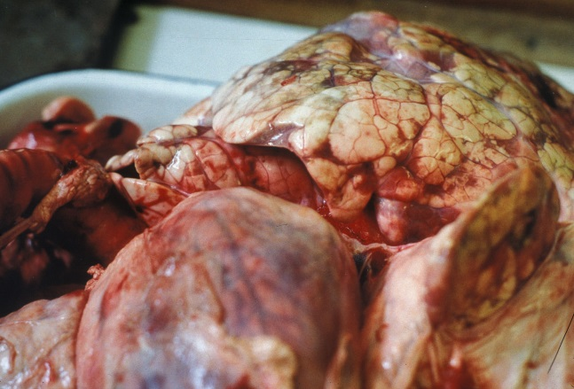
Fig. 2: Varying degrees of emphysema and oedema of the lung can be seen in this picture of a Dictyocaulus infection. Note how thickened the edges of the lung are.

Horak et al. (1983) found a few blue wildebeest in the KNP to have fairly extensive pulmonary lesions caused by Dictyocaulus viviparus (Fig. 3). These lesions did not appear to be severe enough to cause death, but may have debilitated the animals sufficiently to make them prone to capture by predators.
Bronchonema magna is considered non-pathogenic for springbok, its natural host. When springbok were introduced into the Bontebok National Park near Swellendam, bontebok became infected and mortalities occurred. As soon as the springbok were removed, the mortalities stopped. The lesions in the bontebok lungs were similar to those caused by the Dictyocaulus species in other antelope.
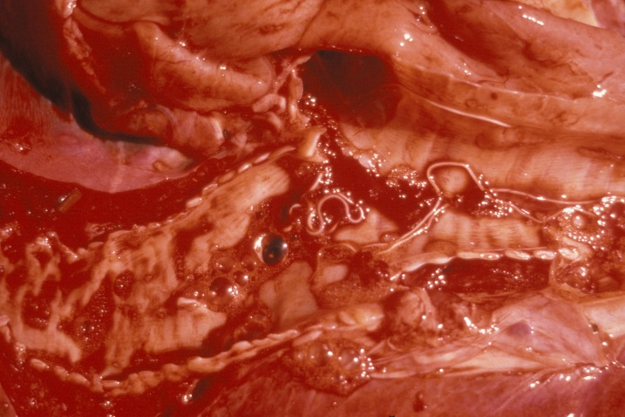
Fig. 3: Dictyocaulus sp. at the bifurcation of the trachea

As the genus name implies, Pneumostrongylus calcaratus (impalas) and P. cornigerus (bontebok) both occur in the lung where they are so intimately associated with the lung parenchyma that it is virtually impossible to obtain intact worms. Pneumostrongylus calcaratus in impalas is so common that it is considered ‘normal’, and apart from localized discolouration and slight fibrosis the lesions cause no discomfort to both the host species (Fig. 4). Gallivan, Barker, Alves, Culverwell & Girdwood (1989) describe P. calcaratus infection in impalas from Swaziland. Van der Walt & Ortlepp (1960) recorded mortalities in bontebok as a result of P. cornigerus infection.
Protostrongylus capensis (bontebok) and P. etoshai (blue wildebeest and gemsbok, respectively) occur in the lung alveoli where no lesions are produced. Muellerius capillaris is primarily a parasite of the lungs of sheep and goats in the Western Cape Province, and have been recovered from impalas, Grant’s gazelles and okapi’s in Kenya (Round, 1968). No pathogenic effects have been described.
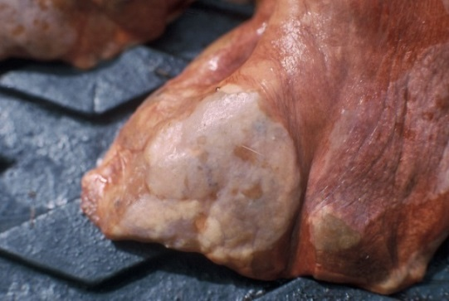
Fig. 4: The lesion caused by Pneumostrongylus calcaratus in the lung of an impala.

Infections of the gastro-intestinal tract

Helminths of the oesophagus and forestomach
The Gongylonema species, of which there are several, occur in the submucosa of the tongue, oesophagus or the rumen. The typical zig-zag pattern in the mucosa is the only indication of the presence of the worms. They are non-pathogenic (Fig. 5).
Like the Gongylonema species, adult Calicophoron, which live in the rumen and reticulum, are non-pathogenic (Fig. 6). Several species occur in wildlife, all of which use a freshwater snail, usually of the genus Bulinus, as intermediate host. Briefly, the life cycle is as follows: Eggs are released with the faeces and must be freed from the faeces, i.e. when they fall into water, before they hatch. The miracidia must enter the host within 3 hours of hatching or they will die. In the snails, the miracidia form sporocysts, then rediae, daughter and granddaughter rediae. The granddaughter rediae produce cercariae which leave the snail, and form metacercariae on the surface of the water or on vegetation. When ingested by the host, they excyst in the small intestine. After 15 to 50 days they migrate up the small intestine, through the various stomachs to end up in the rumen where they develop into the adult flukes.
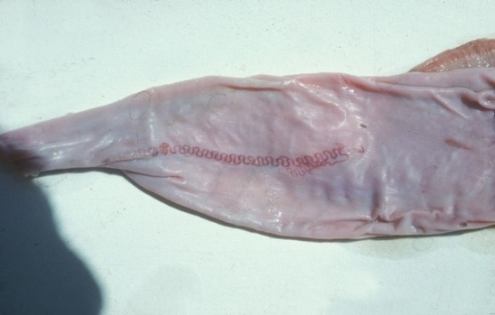
Fig. 5: The zig-zag worm, Gongylonema, in the mucosa of the oesophagus.

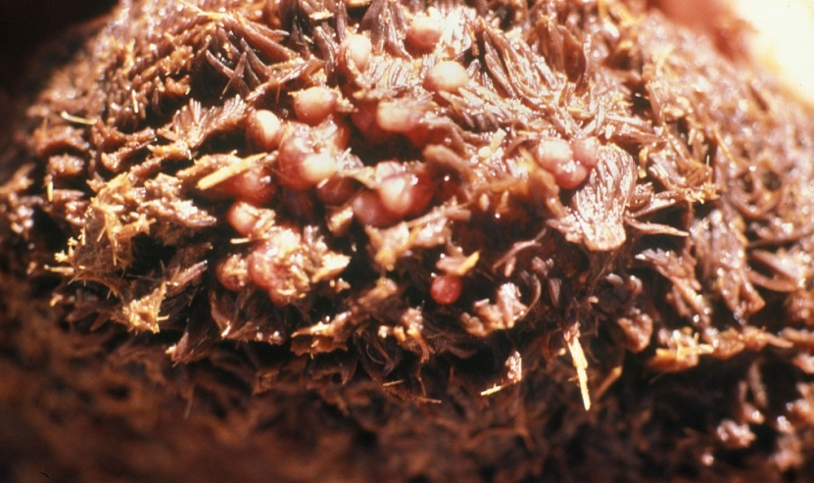

Fig. 6: Adult Calicophoron microbothrium, visible as pink globules hidden between the papillae in the rumen

Helminths of the abomasum
With the exception of the Parabronema spp., the helminths that occur in the abomasum have monoxenous life cycles.
A number of Haemonchus species occur in the abomasum of antelopes, but their pathogenicity has not been studied. From several surveys in the Kruger National Park (KNP) and in some of the KwaZulu-Natal Parks (KZNP) it became apparent that certain Haemonchus species are associated with certain host groups. For example, in the KNP and KZNP, Haemonchus vegliai (Fig. 7) is associated with the browsing antelope (kudu, nyalas and bushbuck) while impalas in the KNP harboured Haemonchus krugeri (Fig. 8). In areas where game and domesticated ruminants graze the same pastures, for example, sheep and blesbok or impalas, the game will harbour Haemonchus contortus, the primary Haemonchus of sheep. This has economic and managerial implications since the wild ruminants can act as reservoir hosts for resistant H. contortus.

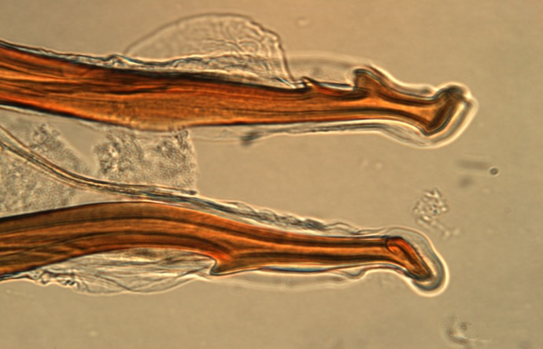
Fig. 7: The tips of the spicules of Haemonchus vegliai from kudus.

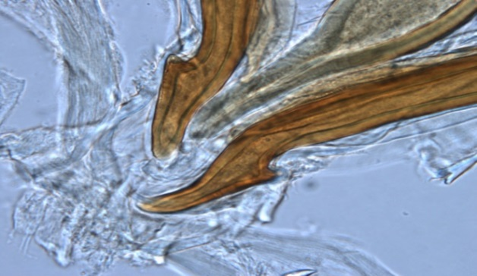
Fig. 8: The tips of the spicules and gubernaculum of Haemonchus krugeri from impalas.

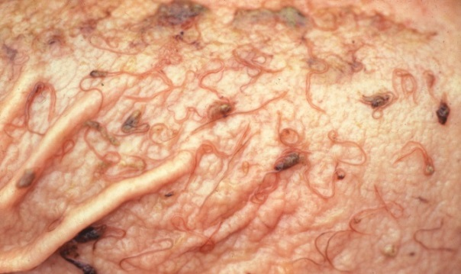
Fig. 9: Haemonchus vegliai in the abomasum of a kudu.

Deaths of sable and roan antelopes and kudus because of resistant H. contortus infections are known. In all cases the clinical signs and gross pathological lesions were the same as for similar infections in sheep.
Teladorsagia, Ostertagia and Longistrongylus all belong to the subfamily Ostertagiinae, and all produce more or less the same kind of lesions in their antelope hosts (Figs. 10 & 11). The lesion is essentially a nodular abomasitis, caused by hyperplasia of the mucosa, which in turn is caused by the nematodes that develop and live in the abomasal glands (Pletcher, Horak, De Vos & Boomker, 1984). The helminths have been described from a variety of antelopes and no adverse effects because of the infection have been seen. Basson, Kruger & McCully (1968, cited in Basson, McCully, Kruger, Van Niekerk, Young, De Vos, Keep & Ebedes, 1976) however, saw fatal cases of ostertagiosis caused by Ostertagia ostertagi in eland that were kept in small camps.

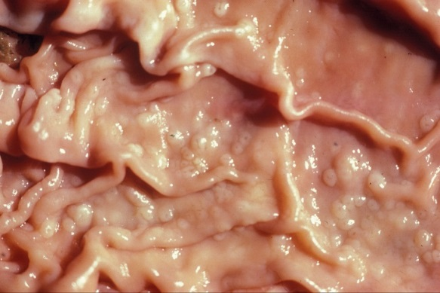
Fig. 10: Nodules caused by Ostertagia ostertagi in the abomasum of an eland.
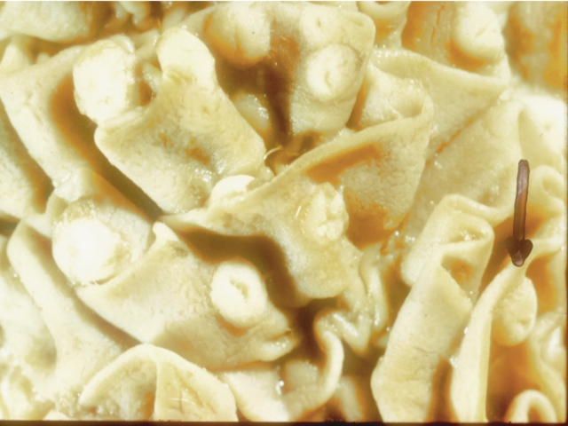
Fig. 11: Nodules caused by Longistrongylus sabie in the abomasum of an impala from the Kruger National Park (arrow).

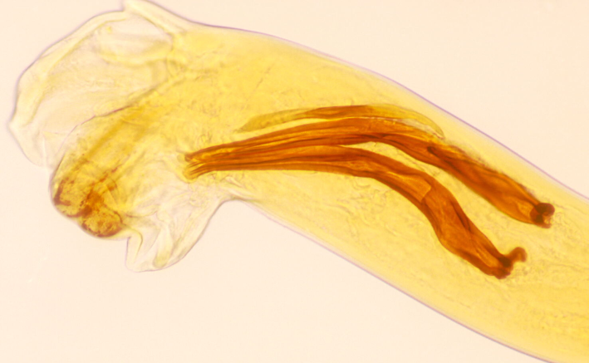
Fig. 12: Lateral view of the spicules of Trichostrongylus thomasi.

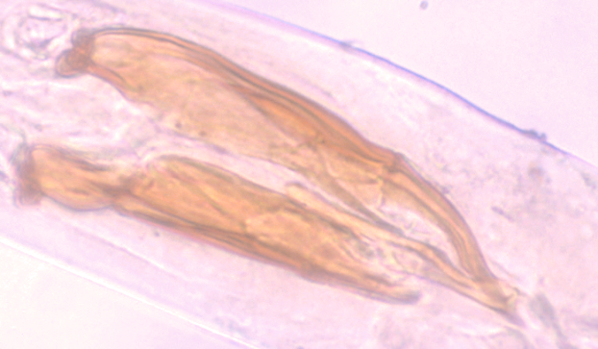
Fig. 13: Lateral view of the spicules of Trichostrongylus axei.

Trichostrongylus thomasi (Fig. 12) is the species usually found in the abomasum of a number of antelope species and it is the counterpart of Trichostrongylus axei (Fig. 13) of domesticated ruminants. This author has neither seen clinical signs nor has he seen lesions as a result of the presence of this parasite.
Different species of Parabronema (Fig. 14) parasitize elephants, rhinoceroses, buffaloes and giraffes in South Africa, and of camels, sheep, cattle and buffaloes in North Africa. All make use of a stomoxid fly, Haematobium or Lyperosia, as intermediate host. The fly larva ingests eggs or first stage larvae of the nematode. The nematode larvae develop to the second stage in the fly larva, and have developed to the infective third stage by the time the fly emerges from the pupa. The fly has to be ingested, either with water or food for the life cycle to continue. Large numbers of worms are often present in the abomasum or stomach, and may or may not cause gastric ulcers.
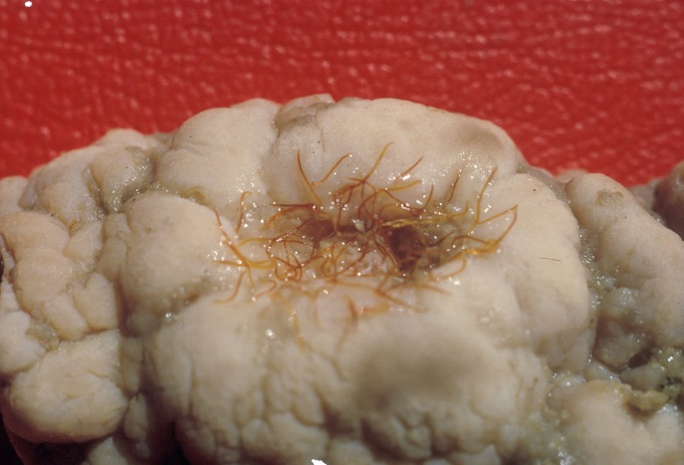
Fig. 14: Parabronema skrjabini in an ulcer in the stomach of an elephant. The lesions in giraffe are very similar.

Helminths of the small intestine
Although immature Calicophoron (= Paramphistomum) spp. (Fig. 15) cause serious disease in susceptible domestic animals, clinical disease has, to the best of my knowledge, not been described in antelope in South Africa, although recently a case in nyalas occurred in the North West Province. This case occurred in animals kept in an enclosure and the intermediate hosts were present in the water supply, a trough.
The strongylid nematode Agriostomum (Fig. 16) occurs in the posterior part of the small intestine, where it on occasion produces ecchymoses on the mucosa. Despite the worms being fairly often encountered, the life cycle is unknown and no clinical signs or pathology have been described.

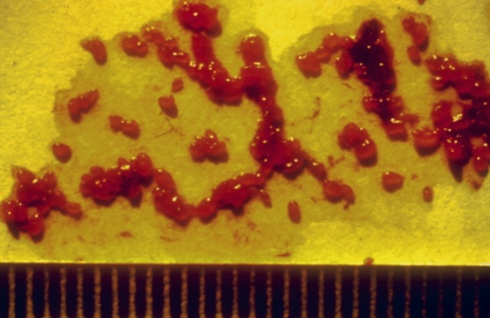
Fig. 15: Immature Calicophoron collected by washing faeces from an affected animal through a sieve.

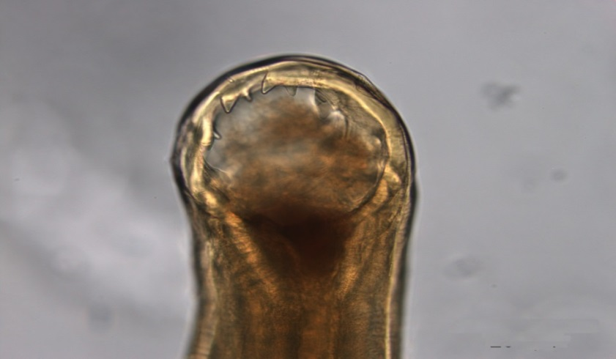
Fig. 16: Dorsal view of the head of Agriostomum gorgonis, a parasite of blue wildebeest and kudus

The family Trichostrongylidae is well represented in all antelope and the commonly encountered genera are Cooperia, Cooperiodes, Nematodirus, Impalaia, Paracoperia and Trichostrongylus. As is evident from Table 5, there are numerous species of especially Cooperia and Trichostrongylus.. Large numbers of worms of any or all the genera mentioned above can occur in antelope, but clinical signs are rarely seen.
Bunostomum trigonocephalum was present in 3 out of 12 impalas culled at Pafuri in the KNP, and all three were approximately 8 months old. Neither showed any clinical disease or macroscopic lesions (Boomker & Horak, unpublished data). Small numbers of Gaigeria pachyscelis have been recorded from blue wildebeest in the KNP, and mostly in the 4-12 month old antelopes, again without clinical signs or macroscopic lesions (Horak et al., 1983).
Moniezia benedeni and Moniezia expansa as well as Avitellina are widely spread in antelope throughout southern Africa, but no clinical disease has been recorded. These tapeworms are usually seen in young animals.

Helminths of the large intestine
Oesophagostomum is a large genus of which two species are commonly encountered in antelopes. These are Oesophagostomum columbianum (Fig. 17) and Oesophagostomum walkerae. The former nematode species has been recorded from at least 18 antelopes, but no mention is made on the pathogenicity of the parasites in their respective hosts. Oesophagostomum radiatum is fairly common in buffaloes in the KNP but the infection is mild (Basson et al., 1970). The nodules that are commonly seen in sheep and goats, and even cattle, are much less conspicuous in antelope.
Several species of the genus Trichuris parasitize wildlife. Trichuris globulosa, one of the more commonly encountered species, occurs in 8 antelope species It is, however, a rare finding in buffaloes and the infection is invariably very mild (Basson et al., 1970), as it is in the majority of antelopes. Because of its monoxenous life cycle, and the infective larva that occurs in a thick-walled egg, large numbers can build up in enclosures and under intensive conditions. In private collections or zoos, this parasite is one of the most troublesome.

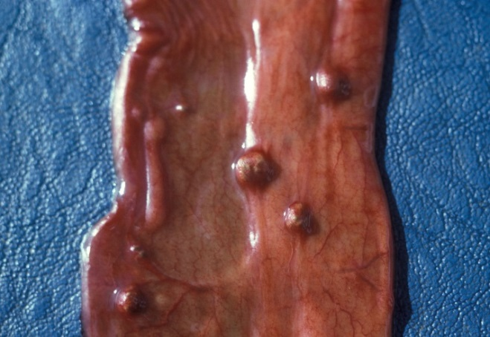
Fig. 17: A piece of large intestine with the nodules that is so characteristic of Oesophagostomum infections in ruminants.

Infections of the liver
Pletcher, Horak, De Vos & Boomker (1988) describe the lesions caused by Cooperioides hepaticae in impalas from the KNP (Fig. 17), and came to the conclusion that members of this genus are usually considered of minor pathological significance, unless present in large numbers and in combination with other trichostrongyles. Gallivan, Barker, Culverwell & Girdwood (1996) described lesions caused by hepatic parasites in general, in the same antelope from Swaziland. Despite the nematodes being present in the majority of impala that were examined during several surveys, clinical signs have never been observed.
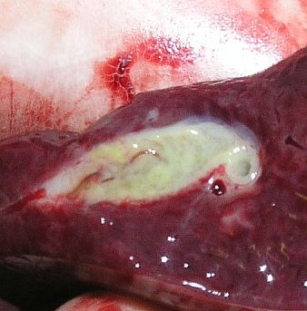
Fig. 17: The greenish discoloration is due to an eosinophil accumulation in the bile duct of an impala as result of Cooperioides hepaticae infection. (Reproduced with permission of Dr. Wilmien Luus-Powell, University of Limpopo).

Monodontus giraffae is an extremely common parasite of the bile ducts of giraffe and causes mild to severe cholangitis, depending on the number of worms present (Basson et al., 1971).
Fasciolosis seems to be a rare occurrence in free-living antelope. Basson et al. (1970) did not find a single case in the 100 buffalo they examined in the southern part of the KNP. Boomker (1990) examined 386 browsing antelope from all over the country and the northern parts of Namibia and found a single grey rhebuck in the Bontebok National Park to harbour only two Fasciola specimens. Boomker & Horak (unpublished, 1980 – 1990) did not find Fasciola spp. in any of the 162 impalas examined from five localities in the KNP, and neither did Heinichen (1973) in the north-eastern region of KwaZulu-Natal. However, Horak (1978) found Fasciola gigantic in one of 36 impala at Nylsvley, Limpopo Province, where they shared pastures with cattle.
Even though antelope seem to be resilient to infections with Fasciola, cases of acute fasciolosis are known. These, however, were present on game farms, or where antelope were overcrowded. In the dry north-western part of Limpopo Province metacercariae of Fasciola were found in water troughs, together with the intermediate hosts, Lymnaea truncatula.
Contrary to Fasciola, the non-pathogenic liver tapeworm, Stilesia hepatica (Figs. 18 & 19) has a high prevalence in a variety of antelope. Buffalo from the KNP, however, did not harbour Stilesia (Basson et al., 1970).
Cysticercosis due to the metacestodes of Taenia hydatigena is a common finding at necropsy of a number of antelope (Fig. 20). After the egg has been eaten, the oncosphere or hexacanth larva hatches and burrows through the wall of the small intestine, crosses the abdominal cavity and enters the liver. It migrates through the liver parenchyma for a while and leaves the liver in the vicinity of the bile duct. It attaches to the mesenterium in the immediate vicinity of the liver. The infection is dependant on the presence of jackal, Cape hunting dogs or domestic dogs. Boomker (1990) found these cysticerci in blue and grey duikers, but associated pathology was not seen. Round (1968) lists 15 species of intermediate hosts for this tapeworm, including warthogs and bushpigs.
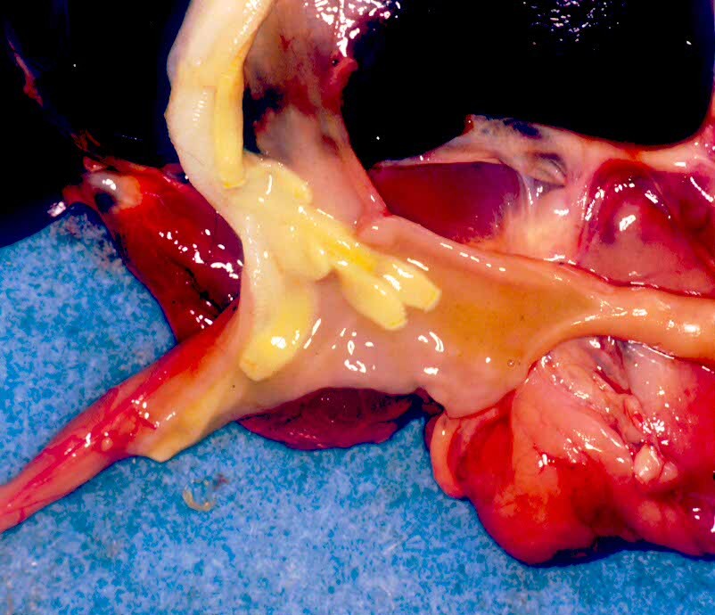
Fig. 18: Stilesia hepatica in the common bile duct and gall bladder of a red duiker, Cephalophus natalensis

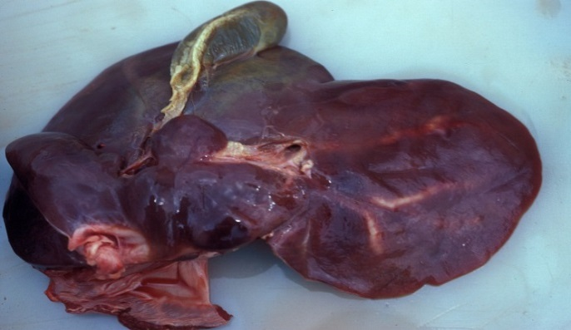
Fig. 19: Stilesia hepatica. Note the thickened bile ducts to the right side of the liver.

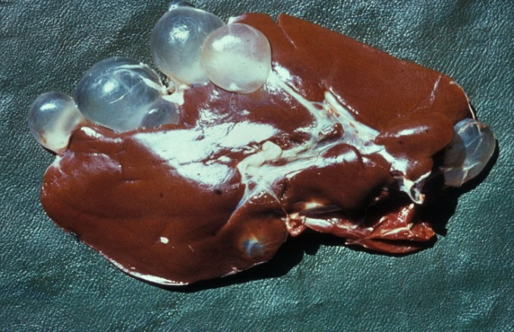
Fig. 20: The typical appearance and localization of the metacestodes of Taenia hydatigena, also known as Cysticercus tenuicollis.

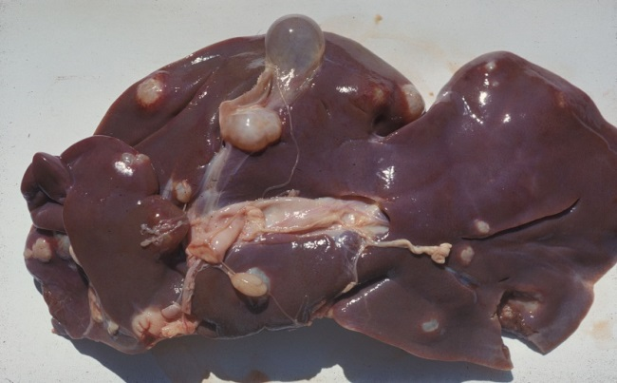
Fig. 21: This photograph of cysts in a sheep liver is presented as illustration of cystic hydatidosis.

Hydatid cysts of Echinococcus granulosus (Fig. 21) were found in one kudu out of the 386 antelope examined by Boomker (1990) and Basson et al (1970) found a 5% prevalence in the buffaloes they processed. Hydatids were not found in the impalas examined by Heinichen (1973), Horak (1979) and Boomker & Horak (unpublished data). Hydatidosis, or cystic echinococcosis does not seem to be of importance in the larger nature reserves but could theoretically become problematic on game farms.
Infective nymphs of the pentastome genus Linguatula are often encountered in antelope (Fig. 22). They utilize antelope as intermediate hosts and the large carnivores, especially lions, as final hosts. The nymphs tunnel in the liver without causing haemorrhage and were found in 63.2% of kudus (Horak, Boomker, Spickett & De Vos, 1992), 21.8% of blue wildebeest (Horak, De Vos & Brown, 1983) and 35.5% of warthogs (Horak, Boomker, De Vos & Potgieter, 1988), all surveyed in the KNP. It is interesting that kudus, which are browsing antelope, have the highest prevalence of this parasite, whereas blue wildebeest, which graze short grass, have the least.
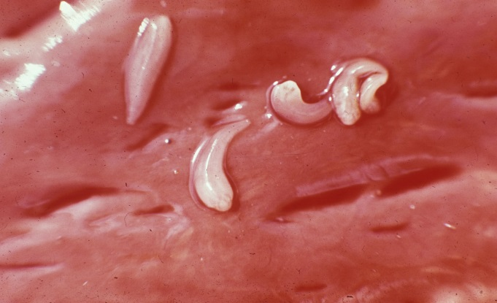
Fig. 22: Infective nymphs of Linguatula nuttalli on the liver of a kudu.

Infections of the cardiovascular system
Elaeophora sagitta (=Cordophilus sagittus) occurs in aneurisms in the coronary vessels (Fig. 23) as well as in the small branches of the pulmonary artery especially in the diaphragmatic lobes (Fig. 24). McCully, Van Niekerk, & Basson (1967) described the pathology of Elaeophora-infections in kudus, bushbuck and buffaloes and Pletcher, Boomker, De Vos & Gardiner (1989) those in kudus from the KNP. Lesions containing live and dead worms were found in bushbuck and kudus from the KNP, bushbuck and nyalas in the northern KZN Parks. The infection seems to occur primarily in the tragelaphine antelope, i.e. kudu, bushbuck and nyala, and rarely occur in buffaloes and cattle. According to Young & Basson (1976) nearly half of 33 eland transferred from the Addo Elephant National Park to the Kruger National Park died suddenly from acute cardiac arrest. Post-mortem examination revealed prominent heart lesions, notably subepicardial aneurysms, associated with the presence of Elaeophora sagitta. In the pulmonary arteries the worms cause a villous proliferation.

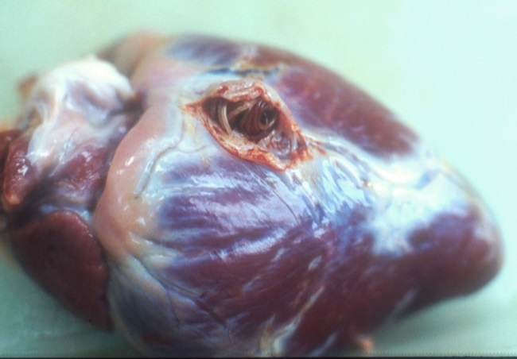
Fig. 23: An opened aneurism in a coronary vessel of a kudu. The rather large Elaeophora is visible at the left.

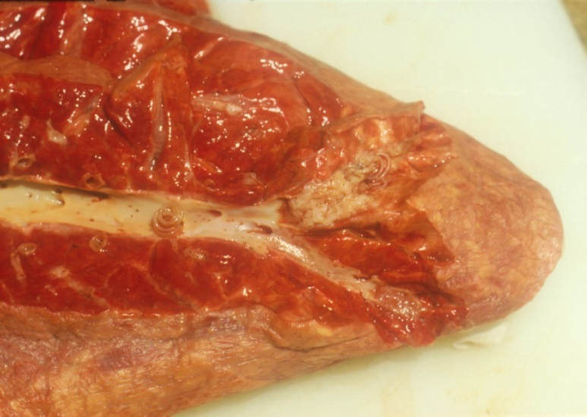
Fig. 24: Elaeophora in the distal pulmonary artery, in the diaphragmatic lobe of a kudu. Note the villous proliferation in especially the top artery.

Schistosoma spp. are common in those animals that are dependant on water, and have been recorded from baboons (Fig. 25), zebras, hippopotami, giraffes, buffaloes and al least 13 species of antelopes in southern Africa. According to Basson et al. (1970), lesions are particularly pronounced in the ‘river buffaloes’, the old bulls that have been expelled from a herd, in the KNP. Severe phlebitis and thrombosis of the mesenteric veins was described in one of these buffaloes (Fig. 26). Eighteen of the 96 kudus examined (18.8%) in the KNP had schistosomes in the liver and mesenteric veins (Boomker et al., 1989b). The prevalence of Schistosoma in impalas from Malelane, KNP was 4.9% and that from the same antelopes from Skukuza, 11.5% (Boomker & Horak, unpublished data). Conversely, no schistosomes were recovered from impalas from Nylsvley (Horak, 1978), impalas from a farm in northern KwaZulu-Natal (Anderson, 1983) and reedbuck in the moist St Lucia area, KwaZulu-Natal (Boomker et al., 1989a).
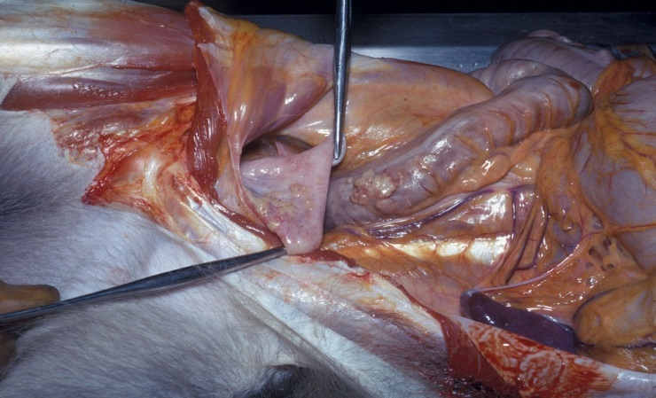
Fig. 24: Granulomata caused by the eggs of a Schistosoma sp. In the rectum and bladder of a baboon.

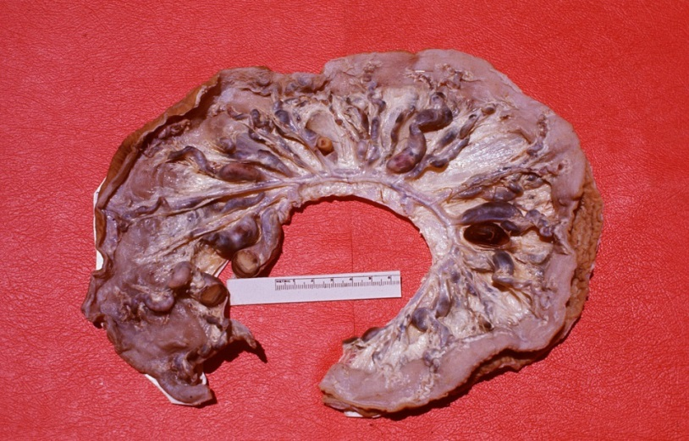
Fig. 25: Severe phlebitis and thrombosis of the mesenteric veins of a buffalo, caused by Schistosoma mattheei.

Infections of the skin and adnexa
Approximately 16% of the buffaloes in the KNP have lesions of one or more of the three species of Onchocerca which occur in buffaloes. The infection manifests as small nodules in the subcutis of the mainly the thoracic, sternal and abdominal regions, but are also present in eyelids, the prepuce and testis (Basson et al., 1970). Unidentified Onchocerca spp. occurs in thirteen species of antelope throughout southern Africa as well as in leopards in Tanzania (Round, 1968).
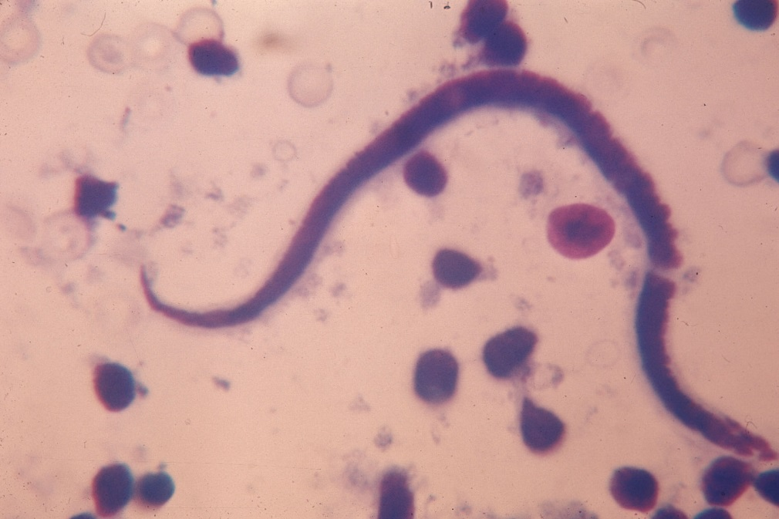
Fig. 26: Microfilaria of an Onchocerca sp. In the blood of a buffalo.

During the late 1980’s and early 1990’s a skin condition was noticed in buffaloes in the KNP, from which Parafilaria bassoni, a filarid nematode that has previously only been recorded from springbuck in Namibia, was recovered. Haemorrhagic perforations or bleeding points were seen dorsally and laterally on the body. Complications due to bacterial infection that cause subcutaneous abscesses, and a type 1 hypersensitivity, that caused large ulcers were seen in a small number of animals. Red-billed oxpeckers often enlarged the bleeding points by feeding on the blood and skin, in the process causing large ulcers. The oxpeckers also played an important part in limiting the spread of the helminths by ingesting blood that contains eggs and first stage larvae (Keet, Boomker, Kriek, Zakrisson & Meltzer, 1997) (Figs. 26-28).
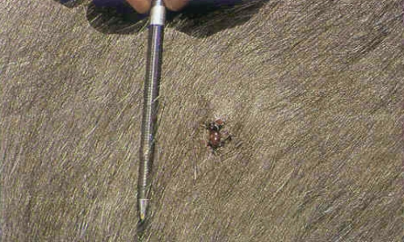
Fig. 27: The lesion caused by Parafilaria bassoni starts out as a small bleeding point.

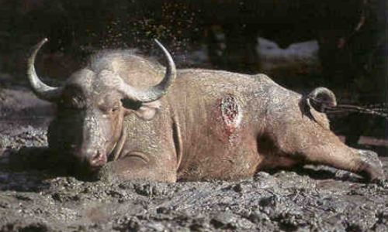
Fig. 28: Oxpeckers enlarge the bleeding point to skin ulcers up to 15 cm in diameter.

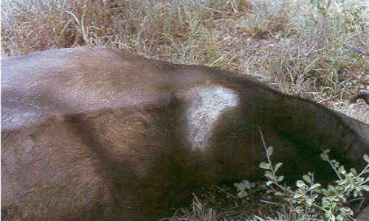
Fig. 29: The skin lesions heal during winter, leaving a distinct scar.

Occasionally the coenuri of Taenia multiceps may be found under the skin or in the intermuscular connective tissue of blue wildebeest, oryx and roan antelope, all three being intermediate hosts. The coenuri are recognized by the flabby “sac” in which numerous protoscoleces are seen. Contrary to what is observed in antelope, only those oncospheres of T. multiceps that end up in the central nervous system and spinal cord of sheep will develop into coenuri. The adult tapeworm occurs in dogs and jackals.
A whole host of microfilariae of which the adult worms are not known, have been reported in the literature, from dik-dik in Ethiopia, giant African otter in the Democratic Republic of the Congo, zebra, waterbuck, bushbuck and warthog in South Africa and steenbuck in Mozambique (Neitz, 1931; Van den Berghe, Chardome & Peel, 1957; Round, 1968; Palmieri, Pletcher, De Vos & Boomker, 1985). These microfilariae may be those of Setaria species, which are quite common in many antelope and warthog in South Africa, or they may represent new species of filarid nematodes. The microfilariae have not been associated with any pathology. However, microfilariae, presumably those of Elaeophora, were associated with mononuclear myocarditis (Basson et al., 1971; Boomker et al., 1989b).

Infections of the musculature
The cysticerci of a number of cestodes are known to occur in a variety of the antelope as well as in warthogs and bushpigs. Most common are those of Taenia crocutae, Taenia hyaenae, Taenia regis and Taenia gonyamai. These can be identified with some measure of accuracy when the hook sizes are compared. Neither the tapeworms themselves in the small intestine of the carnivores nor the cysticerci in the muscles and abdominal cavity of the herbivore intermediate hosts seem have any effect.
Basson et al. (1970) found 29% of the buffaloes they examined in the KNP to be infected with cysticerci, but Boomker et al. (1989b) found only 11.3% of kudus in the KNP to be infected and 3% of reedbuck near Himeville, KwaZulu-Natal, were infected with Taenia hydatigena larvae (Boomker et al., 1989a).

Infections of the nervous system
Setaria labiatopapillosa was found in gemsbok and waterbuck, and both were associated with eosinophilic cerebrospinal pachymeningitis (Basson et al., 1971).

