Ticks
Tick identification
Authors: Prof Maxime Madder, Prof Ivan Horak, Dr Hein Stoltsz
Licensed under a Creative Commons Attribution license.

Importance
Ticks are among the most important vectors of human and animal diseases caused by protozoa rickettsiae, bacteria, viruses and some helminths. They rank second only to mosquitoes as vectors of life threatening or debilitating human and animal diseases. Moreover, ticks transmit a greater variety of infectious agents than any other arthropod group. No wonder that people are afraid of being bitten by a tick.
Apart from the discomfort they cause, these blood-sucking ectoparasites cause considerable production losses especially to improved cattle breeds in the Afrotropical region. Each engorging female tick takes between 1 - 5 ml of blood depending on species and size.
Several Rhipicephalus spp. (R. bursa, R. simus, R. evertsi evertsi, R. evertsi mimeticus, R. exophthalmos and R. warburtoni) and Ixodes rubicundus produce toxins that cause paralysis in cattle, sheep, goats or antelope, whereas Hyalomma truncatum secretes a toxin in its saliva that causes sweating sickness in cattle and deep and very painful wounds in domestic dogs.
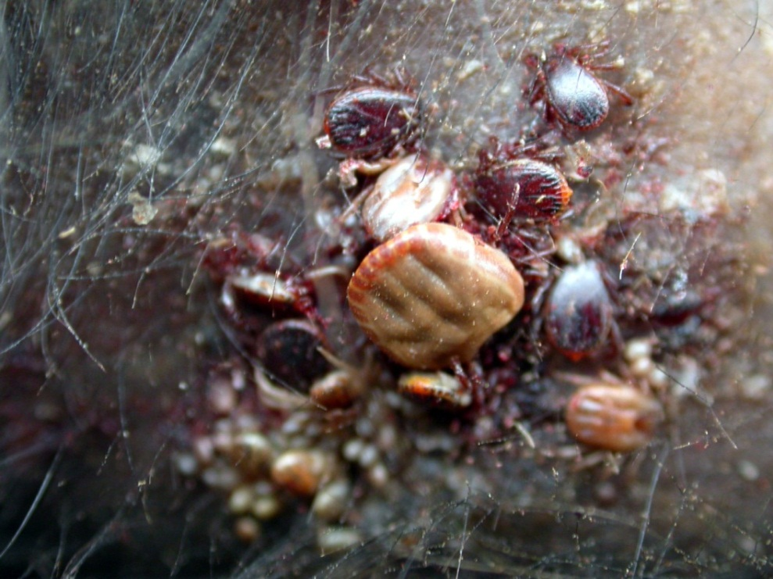
The ear of an animal parasitised by the brown ear tick, Rhipicephalus appendiculatus, the vector of the protozoan causing East Coast fever (ECF). Note the size of engorged females compared to the much smaller males
Although most tick species that infest cattle cause a certain amount of damage to their hides, it is particularly those species with long mouthparts that cause considerable direct damage to cattle hides. Secondary
bacterial infections of the wounds caused by the mouthparts of ticks can result in abscesses, while septic wounds on the teats of cows may affect milk production and the suckling of calves. If the udders of heifers are not protected from the bites of ticks with long mouthparts only a single quarter of the udder and one teat may be functional when they calve. In the case of Amblyomma variegatum, a relationship with the occurrence of bovine dermatophilosis exists although the exact mechanism is not known.

